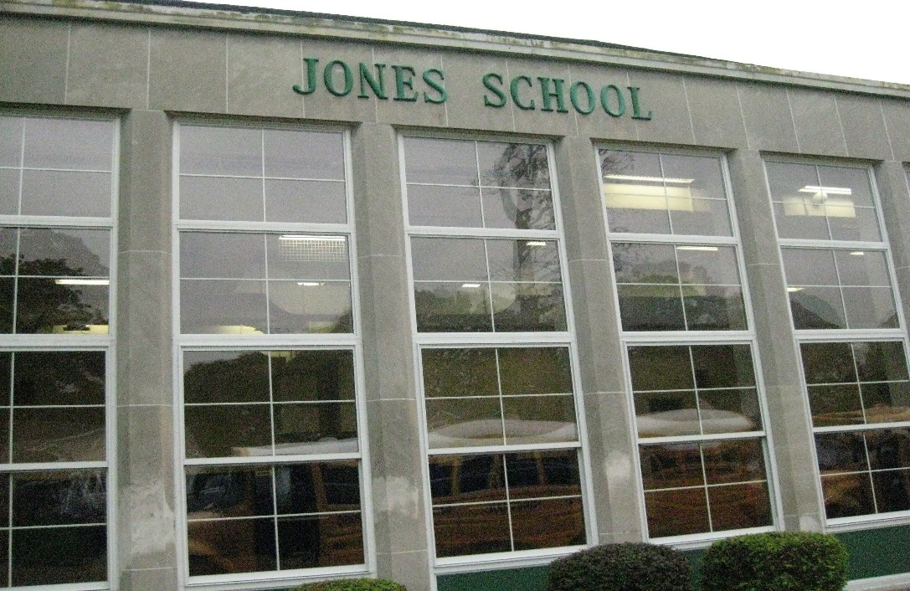

MINIMUM CAPACITY :-
The Minumum intake capacity
of students is between 300-620
children

LIBRARY :-
The Libarary is Available.

CANTEEN:-
The Canteen Facility is Available.

BOARDING :-
No availablility of boarding.

SPORTS :-
There are different categories
sports available.
Girls Volleyball
Boys Volleyball
Football

HUGH R JONES ELEMENTARY SCHOOL
UTICA - SCHOOL

School Detail :-
Hugh R. Jones Elementary School, in partnership with its students, parents, and community, offers each student the opportunity to achieve a superior education, by providing quality instruction and challenging learning experiences, in a safe and orderly environment, which will foster life-long learning and responsible citizenship.

